900151 CO2/O2 NEMA-4 Shipping Container (CAT) Headspace Gas Analyzer
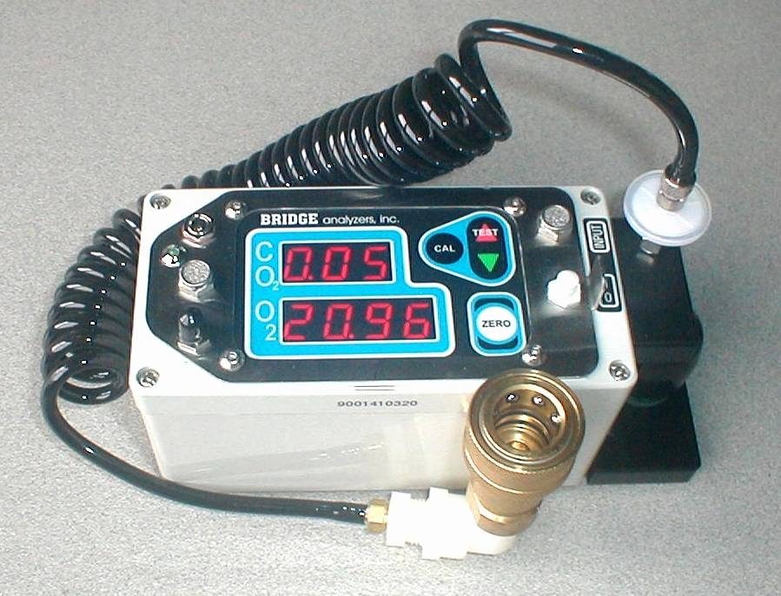Model 900151 (CO2/O2) container headspace gas analyzer with BH3-60 coupling and 6 ft line.
The Model 900151 gas analyzer is used to measure the Oxygen and Carbon Dioxide level in a Controlled Atmosphere Transport (CAT) shipping container. The analyzer is fully wash-down protected and is housed in a very compact NEMA-4 case, measuring only 6 ¼ L x 3W x 3 ½H and weighing 2.5 lbs. The analyzer is fully sealed against the environment and protects the internal electronics from water and dirt intrusion, allowing the analyzer to be washed down with water after use. It also contains an internal NiMH battery pack that will operate the unit on a standalone basis for up to 6 hours.
The analyzer is controlled by an internal microprocessor, and uses time-proven NDIR technology for CO2 measurement and a rugged chemical sensor for O2 analysis. All operating controls are by means of a sealed membrane switch – and the analyzer consumes a mere 2 ½ Watts during operation. (A detailed specification is included at the end of this description.)
Gas is sampled from the container by means of the gas port – an industry standard BH3-60 quick disconnect male fitting on the container. Be disconnecting the input gas line and connecting the analyzer to the container, the container ambient gas is drawn into the analyzer by means of the built-in analyzer sample pump, analyzed, and the gas data presented on the bright ½ inch LED displays.
The analyzer contains an internal water trap and protective filter to prevent any contamination or moisture in the sample gas from reaching the analyzer optics.
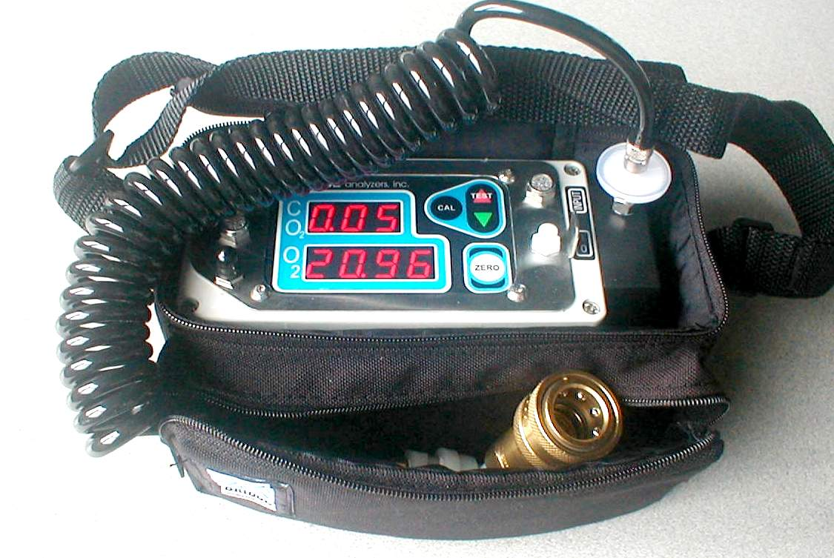Model 900151 CAT CO2/O2 Analyzer – Showing Operation Configuration in Soft Case
As can be seen above, the Model 900151 is a totally sealed unit. All gas and control access is from the top of the unit, including battery charging and Digital Communication (through the sealed connector just below the battery charger input). Operating controls are by means of a sealed membrane-switch assembly – and the power switch is a toggle switch at the center-right side of the case, protected by a flexible white boot. The gas input is a Luer-Lock female fitting at the top/right of the case, including a 25 MM filter at the end of the coiled sample line.
The Model 900151 is a CAT (Controlled Atmosphere Transport) portable gas analyzer, used to measure CO2 and O2 gas levels inside a shipping container. Gas is measured by sampling the output of a BH3-60 male gas port of a shipping container. Sample gas may be drawn and measured either continuously or by a sample and hold method, where it is drawn either continuously or for 20 seconds (Sample/Hold Mode) from a BH3-60 female quick disconnect connector through a 6 foot sample line and water trap at 250 ml/min.
The Model 900151 is designed for measuring either natural respiration or gas enhancement, and has a full 100.0% CO2 /O2 range, but is also auto-range switching to improve low gas accuracy for gas values under 10.0%. The Oxygen sensor is an advanced, thermally compensated design, and has a life of 12 months in typical operation, and the CO2 is measured by a rugged NDIR optical head.
The analyzer may also be operated in the protective soft-case and as it is battery-powered and totally self-contained, it can easily be carried from location to location and operated continuously for long periods of time. The analyzer also may be operated off 110 /220VAC power using the external power supply provided with the unit.
Products are complete with soft case, sample line, coupling, and filters (1 spare), manual, and battery charger/remote power. All of the analyzer components and accessories fit into the soft-foam-filled nylon case, making for a clean, complete package that can be stored or shipped without concern. The analyzer can either be operated in the soft case for additional shock protection (the soft case has a shoulder strap for easy hands-free transport), or removed from the case for operation as a standalone unit. The analyzer is fully sealed against water for superior environmental protection, and can even be washed down at the end of use.

900151 - CO2/O2 Shipping Container Headspace Gas Analyzer Specifications
Gases Measured: | Carbon Dioxide (CO2), and Oxygen (O2)
Measurement Methods: | CO2: NDIR (Non-Dispersive Infra-Red.)  O2: Electro Chemical Sensor
Measuring Ranges: | CO2: 0.00-100.0%  O2: 0.000-100.0%
Resolution: | CO2: 0.01% Below 10.0%, 0.1% above 10.0%,  O2: 0.001% Below 10.00%, 00.01% above 10.00%
Accuracy  Repeatability | 5% relative to gas reading.  1% relative to gas reading.
Response time: | 15 seconds to 95% Final Reading,  20 Seconds to 99% Final Reading.
Sampling Rate: | 4 ml/sec
Sample/Hold Time | Factory default 20 Seconds. Adjustable in 1 second increments.
Internal Gas Contaminate Protection | Internal water trap and water blocking / particle filter protects pneumatics and optical components from gas-borne contamination.
Start-up  Warm-up: | 10% Relative Gas Data 30 seconds from power up.  Full accuracy in 5 minutes.
Operating Temperature: | 0 to +40 degrees C.
Power: Line Power  Internal Battery | 110VAC / 220VAC (EURO) Wall Supply  NiMH battery pack, 6-8 hours operation per charge.
Battery Charger/ External Supply: | 110 to 220 VAC 50/60 Hz Standard
Weight: Unit Alone  In Soft Case | 2.5 Lbs.  3.5 Lbs.
Size: Unit Alone  In Soft Case | 6 ¼ L x 3W x 3 ½H  8 ½L x 5W x 5H
PC Interface: | Fully Sealed Serial Port, 9600 baud.
CAT Analyzer accessory products:
P/N 108126 – 25 mm Dia Filter 6-Pack:
This 6-pack of sample filters should last for 12 months of typical use. They are installed at the end of the sample line just before the analyzer input and prevent contaminants from entering the analyzer.
P/N 001140 – Oxygen Sensor:
This is a user replaceable item – and has a useful life of 12 to 18 months.

